Database Systems - Report



Saavi Deshpande 2021A7PS2436P

Shardul Wadajkar 2021A7PS2419P

Anti-Plagiarism Statement

*The members of this group hereby declare that this project was done by us by ourselves. The code that this project uses was written by the members of this group, and no part of it is copied from any online forum, friends, or other sources.*

*The project report itself is also compiled by the members of this group by themselves. The sources of any illustrations, references, etc are duly mentioned in the end.*

*We also declare that we have duly taken note of the consequences of plagiarism, and we have not allowed, nor will we in the future allow anyone to copy our work and pass it off as their own.*

*Dated : 11th April 2023*

Grading Management System for Schools

The Grading Management System is a centralized database management system designed for schools to efficiently store, manage, and report grading data. The system provides an easy-to-use interface for teachers to enter and update grades for various assessments. We have made these assessments as they are currently used in CBSE Board schools. There are 4 major exams throughout the year for each subject, the pre-mid term, the mid-term, the post-mid term and the final term. These have fixed weightages for every subject. The system enables teachers to view grade records across multiple classes that they teach in and generate reports on student performance.

The system has a comprehensive database containing all the required information about students, classes, grades, and assessments. The system will provide access controls like login and password to ensure that only authorized personnel can access the system. The students have access to the database to view their performance and grades. The system generates automated reports for teachers, administrators, and students, providing them with detailed information on student performance and progress.

Entity Relationship Diagram

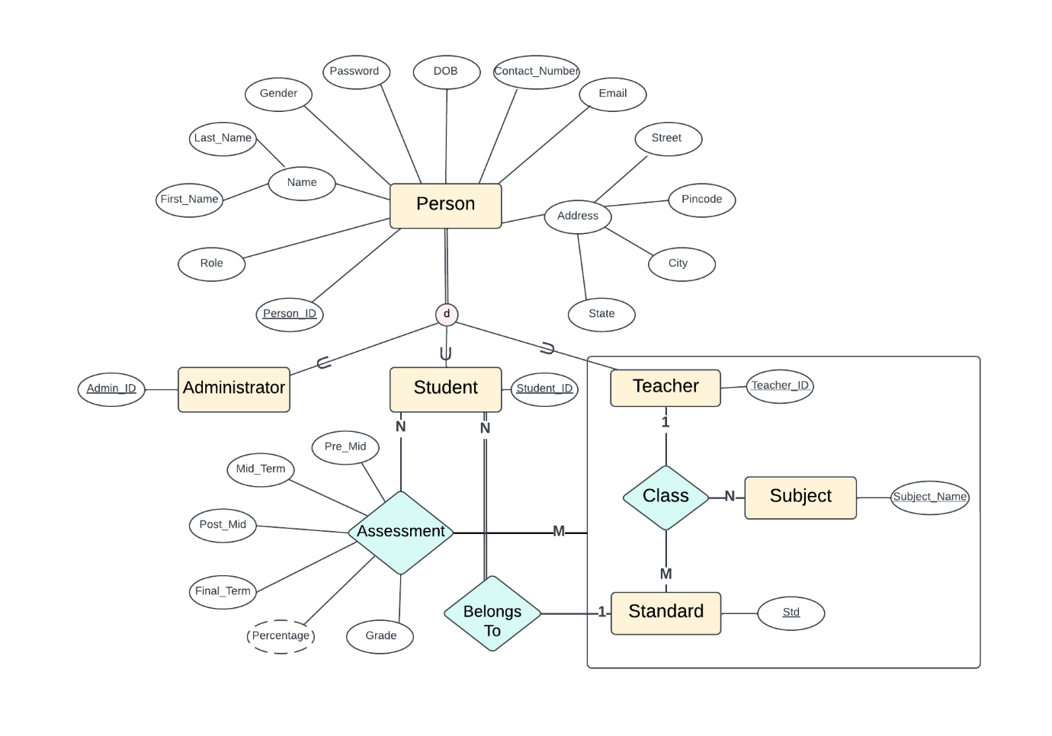

* Concept of the ternary relation
* Concept of generalization
* Concept of aggregation
* Cardinality ratios and total participation
* Concept of derived attribute and composite attribute

Conversion and Normalization

After 1NF Reduction:

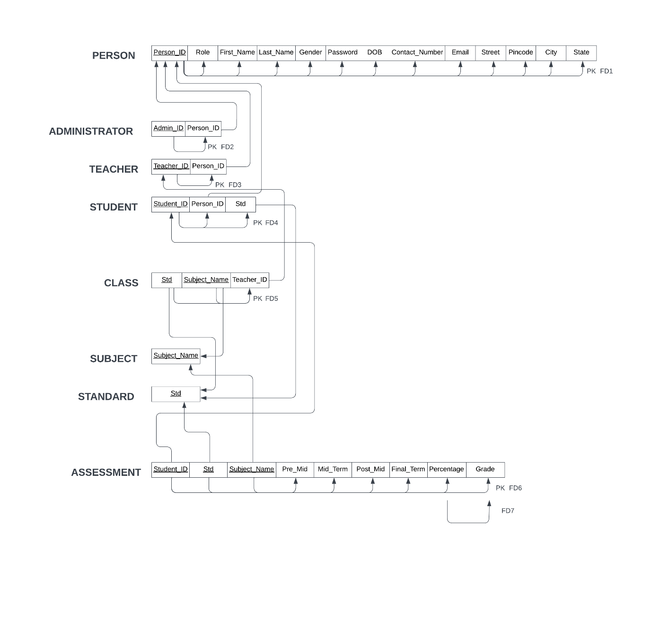

The above schema is in 1NF as the composite attributes ‘Name’ and ‘Address’ have been decomposed into separate attributes. We did not have any multivalued attributes; hence the above schema is 1NF reduced.

The above schema is already 2NF reduced as all non-prime attributes depend on the primary key.

After 3NF reduction:

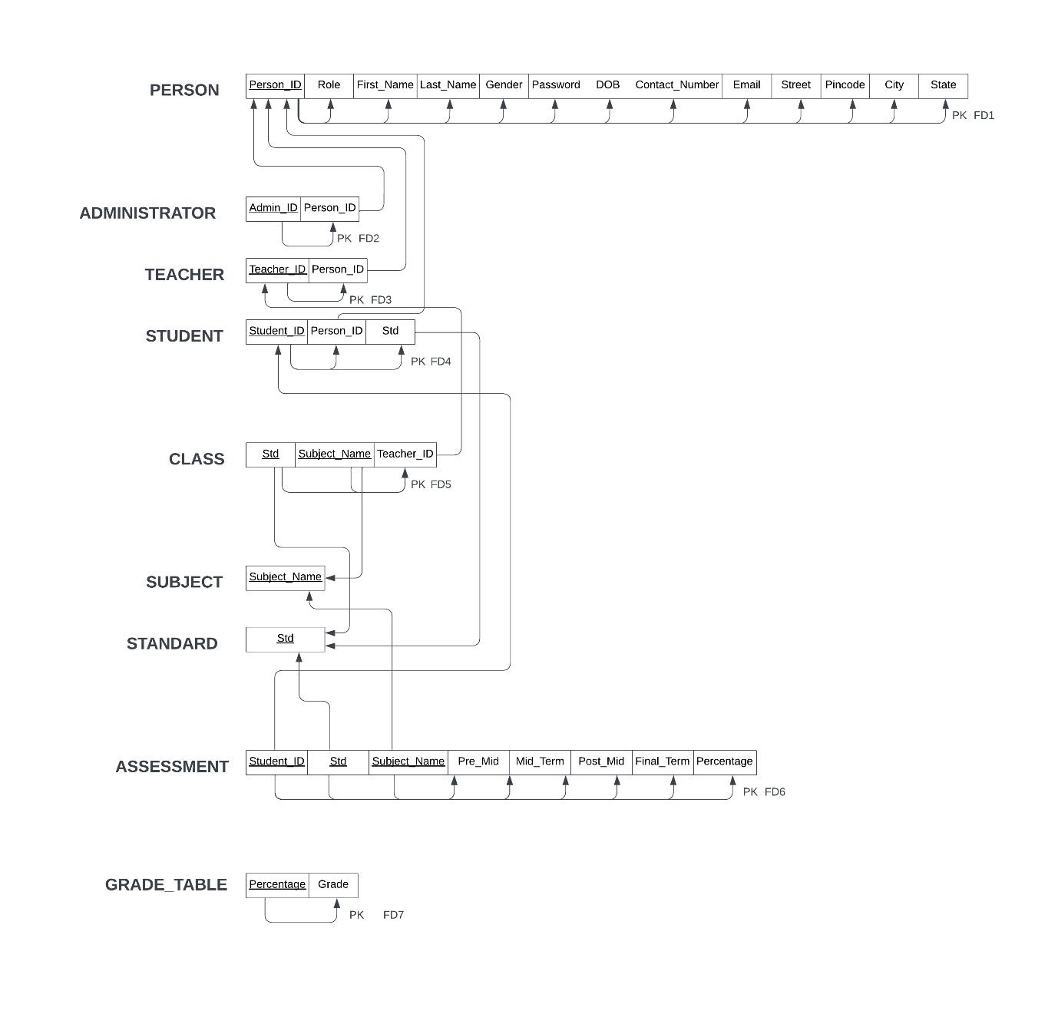

Queries and their Screenshots

Create schema:

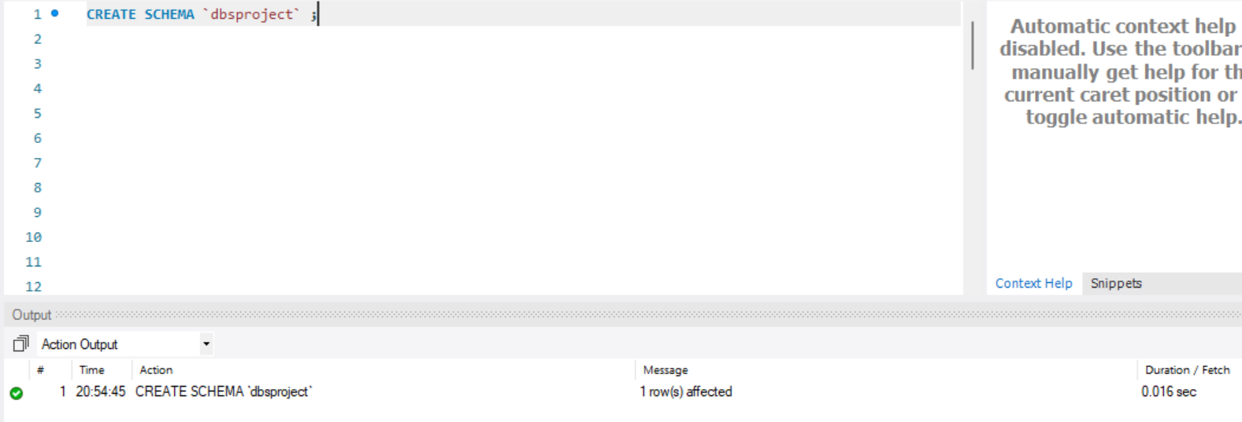

Create tables:

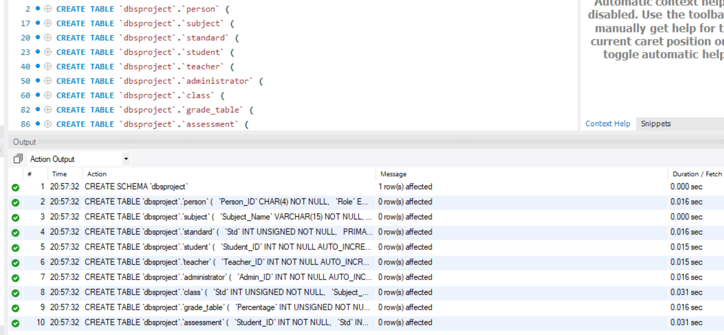

Entering Sample Data:

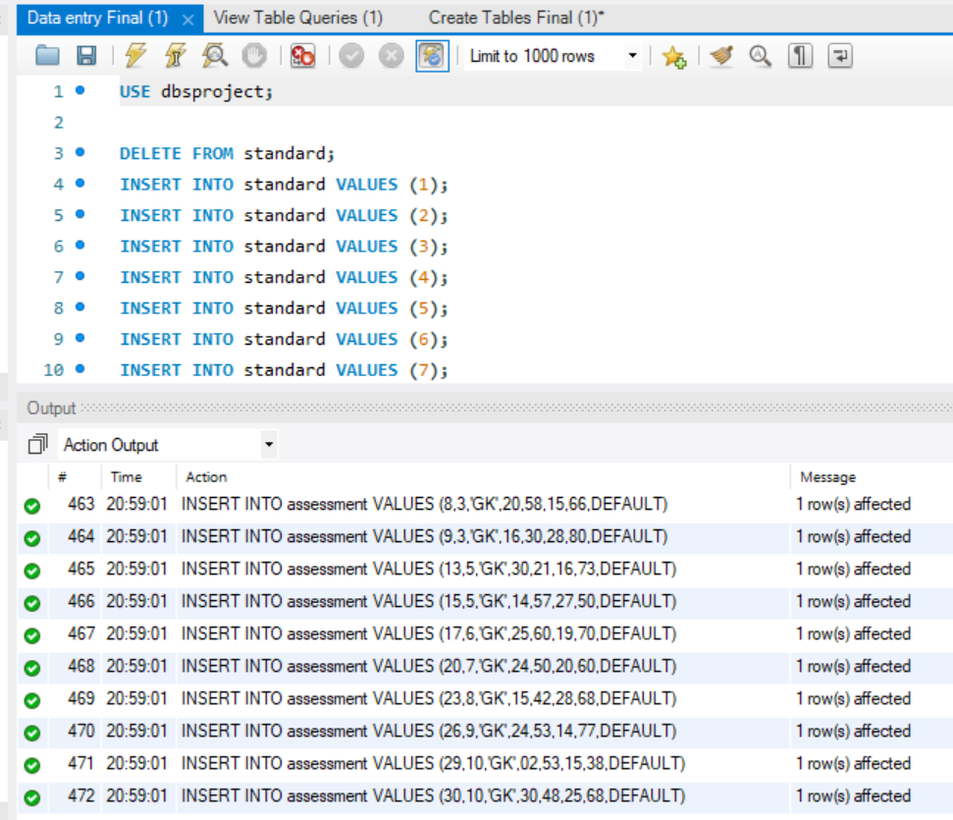

Inserting a new student into student’s table:

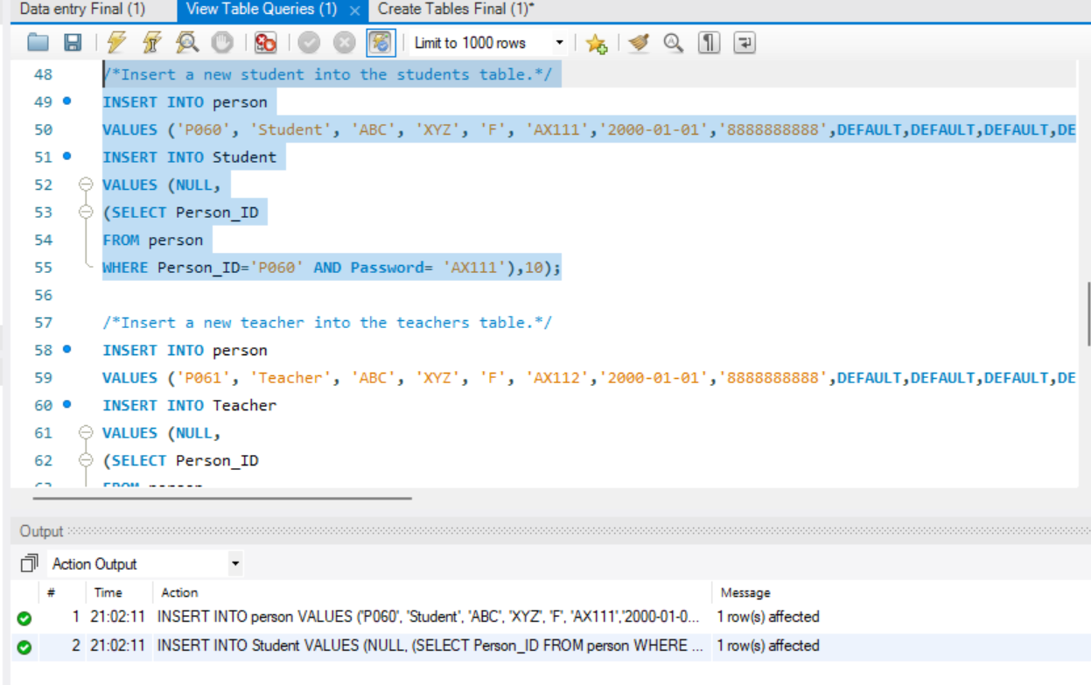

Checking if new student got inserted:

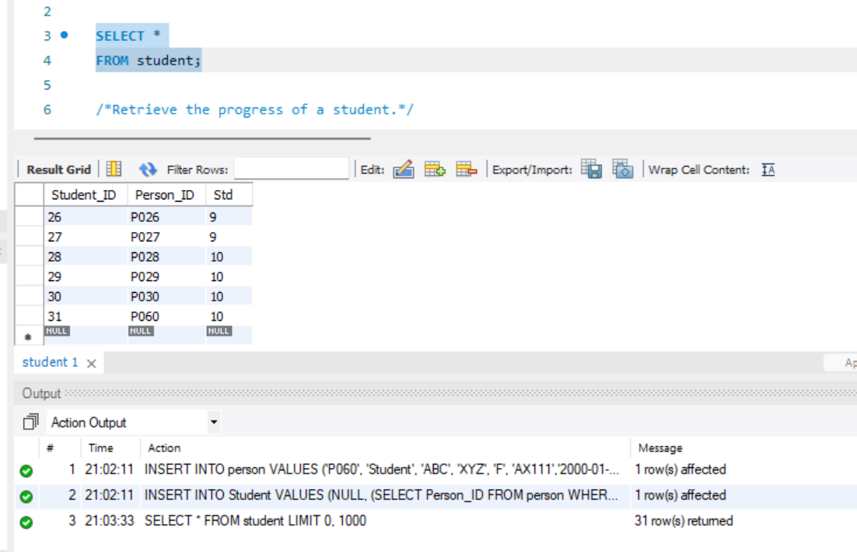

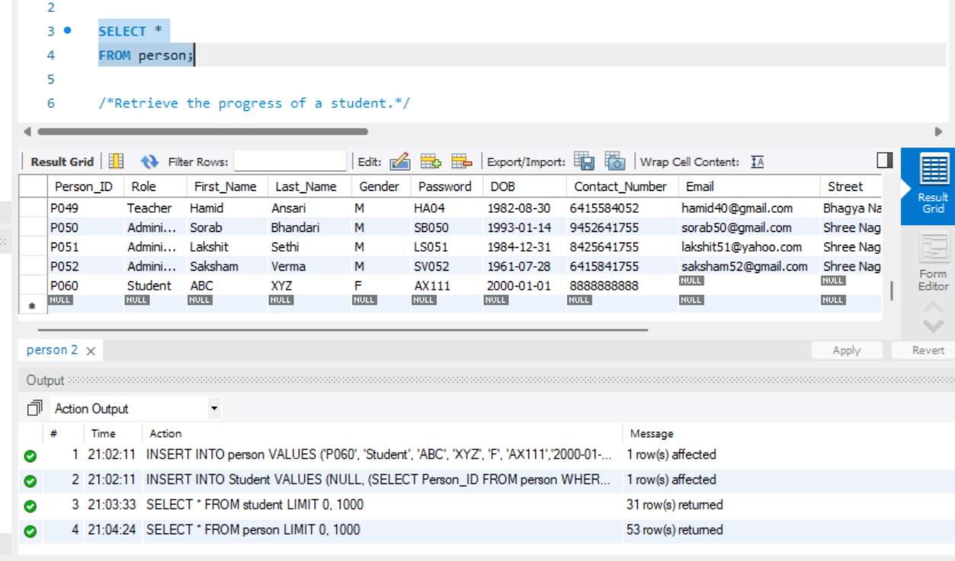

Inserting a new teacher into teacher’s table:

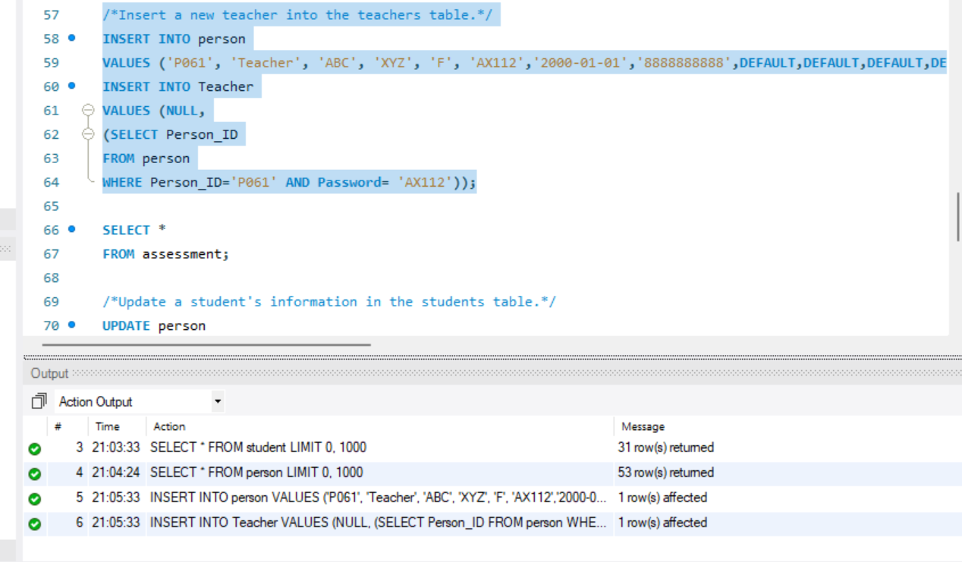

Checking if new teacher got inserted:

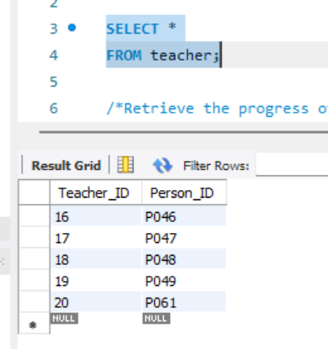

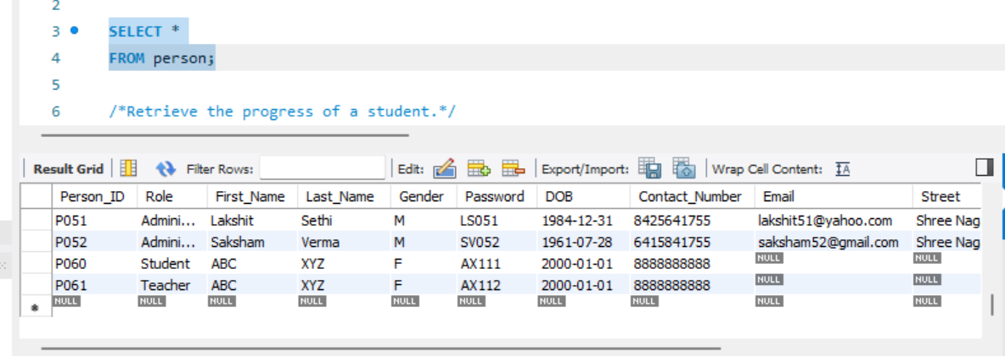

Update a student’s information:

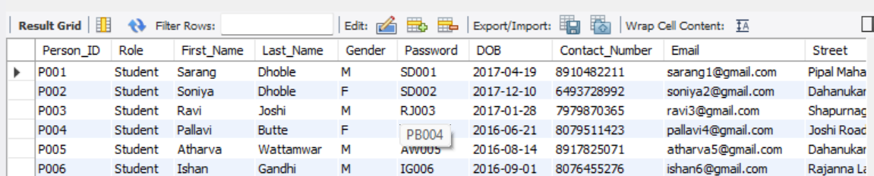

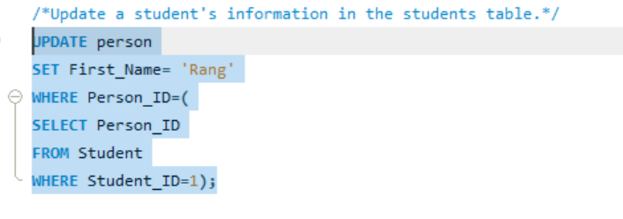

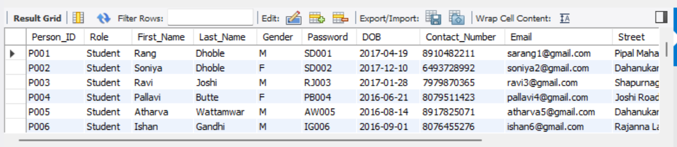

Delete a teacher:

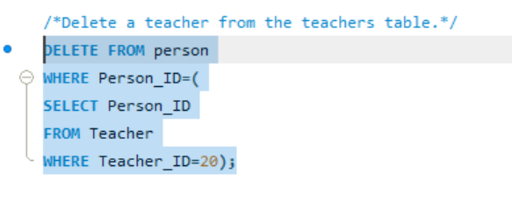

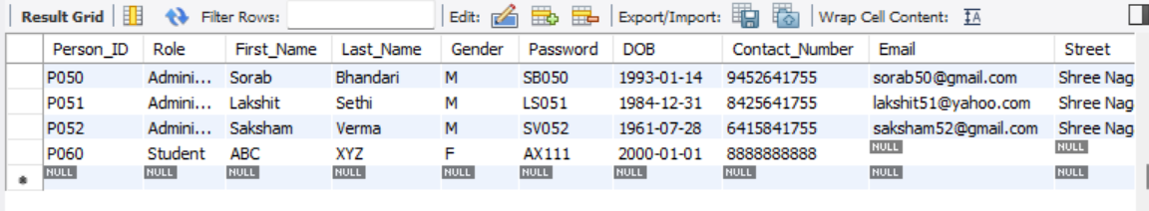

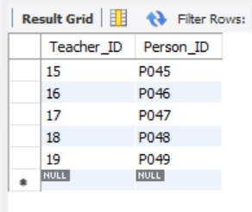

Retrieve all information of a student:

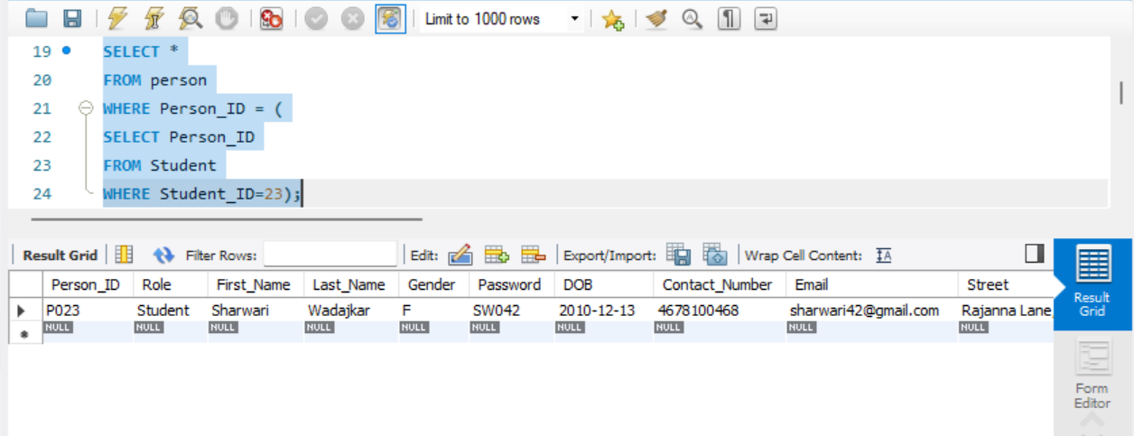

Retrieve the number of students who scored above a certain grade for a specific course for a specific class:

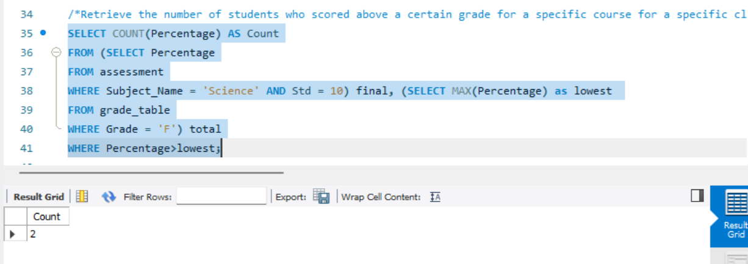

Retrieve the lowest grade from a specific standard and subject:

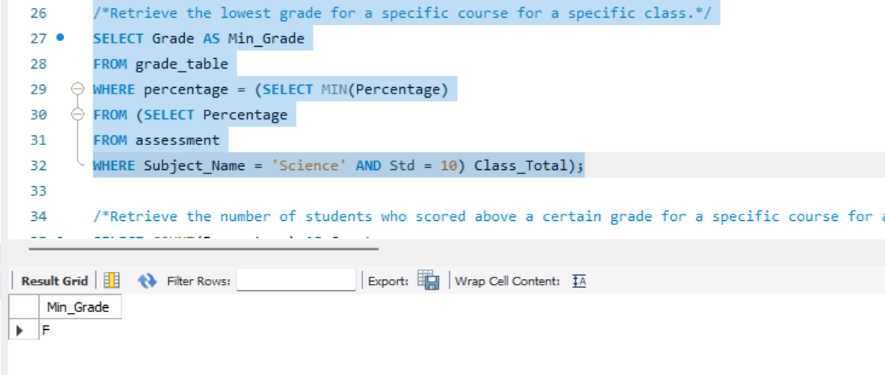

Retrieve the progress of a student:

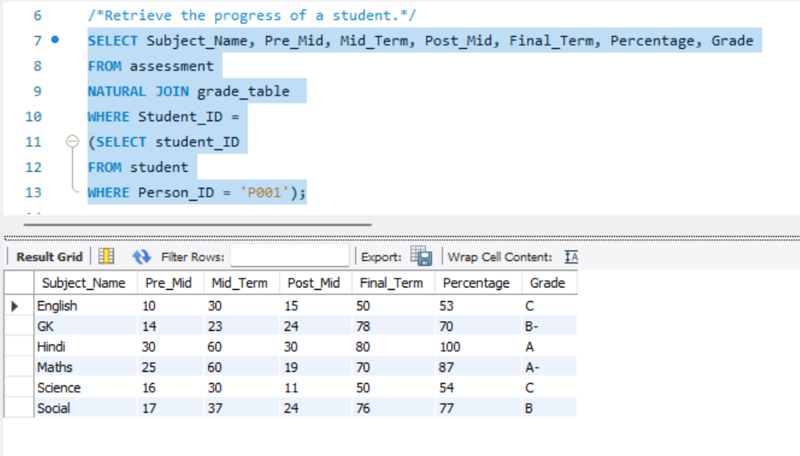

Update a student’s marks:

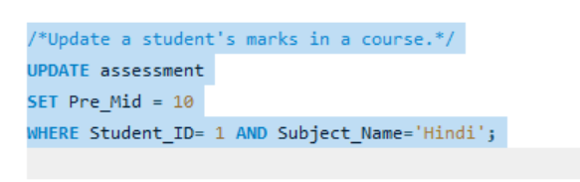

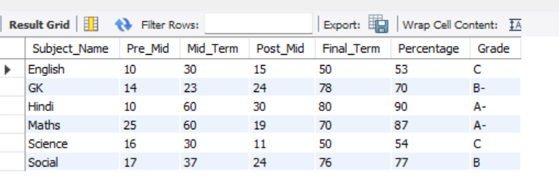

DRIVE_LINK: https://drive.google.com/drive/folders/1wD868628nPR4DZyFmB9bzgBzGLy8OeFU?usp=sharing